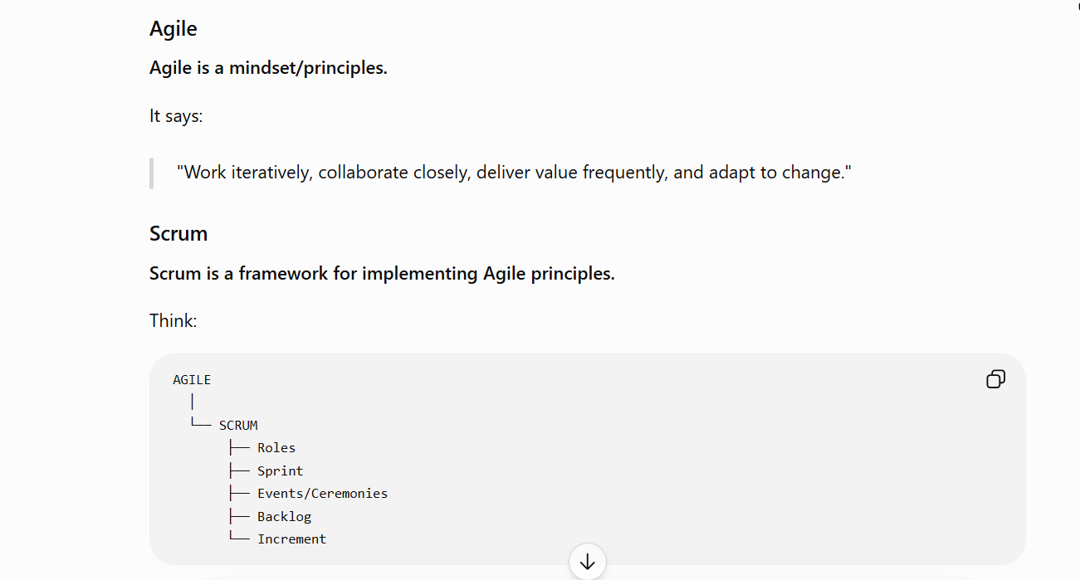

A Sprint is a fixed period during which the team works on a selected set of work and produces a usable increment.
👥 Scrum Team
You should know three major accountabilities.
1. Product Owner — PO
The PO represents the product/business perspective.
They care about:
What should we build and why?
2. Scrum Master
Scrum Master helps the team follow Scrum and removes/processes impediments.
They care about:
Is the Scrum team working effectively?
3. Developers
In Scrum terminology, "Developers" can mean the people who create the product—not necessarily only programmers.
That can include:
- Software developers
- QA engineers
- Automation engineers
- Other technical contributors
The team collectively works toward the Sprint Goal.
🧩 Now the Sprint Ceremonies
This is what you specifically asked for.
You'll commonly hear:
- Sprint Planning
- Daily Scrum
- Sprint Review
- Sprint Retrospective
And don't forget:
Backlog Refinement is also commonly performed, although Scrum formally treats it as an ongoing activity rather than one of the four official Scrum events.
🚀 1. Sprint Planning
This happens at the beginning of the Sprint.
The team asks:
"What are we going to accomplish in this Sprint, and how will we do it?"
Suppose the Product Backlog contains:
P1 - Login
P2 - Password reset
P3 - Document upload
P4 - Document download
P5 - User permissions
P6 - Audit logs
The team can't necessarily do everything.
So they select work based on:
- Priority
- Capacity
- Dependencies
- Complexity
- Sprint Goal
Suppose they choose:
Sprint Goal:
Enable users to securely upload documents.
🔥 QA's role
This is where you should pay attention.
Don't sit quietly.
You should ask:
"What's the maximum supported file size?"
"What file formats are supported?"
"What should happen if upload fails halfway?"
"What permissions are required?"
"What is the expected API response?"
"What are the acceptance criteria?"
These questions can expose requirement gaps before development starts.
That's valuable QA.
⚡ 2. Daily Scrum
Usually around 15 minutes.
Purpose:
Synchronize the team and inspect progress toward the Sprint Goal.
Traditionally people talk about three questions:
What did I accomplish?
What will I work on next?
What impediments are blocking me?
But don't get obsessed with those three questions as a rigid script. The real purpose is:
Developers inspect progress and adapt their plan for the day.
🧨 3. Sprint Review
At the end of the Sprint, the team demonstrates the increment to stakeholders.
Imagine your team built:
Document Upload.
You demonstrate:
Login
↓
Open Documents
↓
Upload PDF
↓
Validation
↓
Success
Stakeholder says:
"Actually, customers also need DOCX files."
Now the team has new information.
That can become future backlog work.
Key point:
Sprint Review is NOT just a demo.
It's an opportunity to inspect the product and gather feedback from stakeholders.

🧠 QA's role in Sprint Review
QA can explain:
- What was tested
- What scenarios passed
- Known limitations
- Important defects
- Automation coverage
- Quality risks
For example:
"The upload feature passed functional and API testing. We currently support PDFs up to 100 MB. Performance testing for concurrent uploads is planned separately."
That's much more professional than:
"Testing completed."
- Sprint Retrospective :
Sprint Review asks:
"How is the product?"
Retrospective asks:
"How did the team work, and how can we improve?"
The team discusses things such as:
What went well?
Automation was added early.
Developers provided API documentation.
What didn't go well?
QA environment was unstable.
Requirements changed late.
Test data wasn't available.
What should we improve?
Create test data before Sprint starts.
Add API contract review.
Set up automated deployment to QA.
The goal is continuous improvement, not blaming people.

- Backlog Refinement :
The Product Backlog contains work that may be vague:
"Improve document management"
That's too broad.
The team discusses it and breaks it down:
Upload PDF
Validate file type
Validate file size
Display upload progress
Handle upload failure
Add permissions
Add audit logging
They clarify:
- Requirements
- Acceptance criteria
- Dependencies
- Estimates
- Technical questions
This makes upcoming work easier to pull into Sprint Planning.

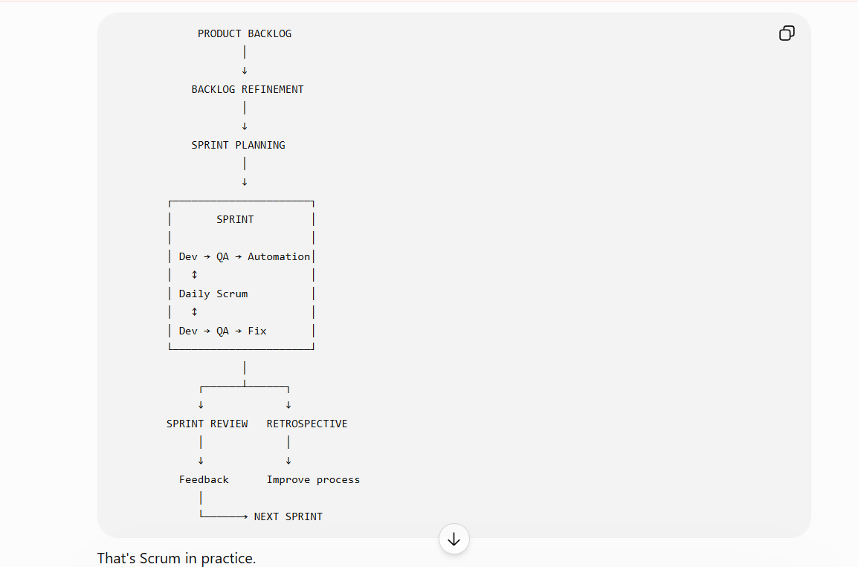
Imagine you're in a Sprint.
Sprint Goal:
"Implement password reset."
Developer says:
"Password reset is done."
You should immediately start attacking it.
Functional
Valid email
Invalid email
Unregistered email
Expired reset link
Already-used reset link
Security
Can someone reset another user's password?
Can reset tokens be reused?
Does the token expire?
Can the token be guessed?
Boundary
Password = minimum length
Password = maximum length
Password below minimum
API
POST /reset-password
Check:
Status code
Response body
Headers
Token behavior
Database update
Automation
Then automate the stable regression scenarios.
Now you're not merely participating in Scrum.
You're contributing engineering value inside Scrum.
"What is the role of a tester in Agile?"
A strong answer:
"In Agile, QA is involved throughout the Sprint rather than waiting until development is completely finished. QA participates in requirement discussions, identifies ambiguities, helps define acceptance criteria, prepares test cases and automation, executes functional/API/UI testing, reports and verifies defects, performs regression testing, and contributes to the Sprint Review and Retrospective."
"Developer completed the feature on Day 13 of a 14-day Sprint. What will you do?"
"I'd communicate the testing scope and risk immediately. I'd prioritize critical acceptance criteria and high-risk scenarios first, execute available automation, and clearly communicate any remaining coverage or release risk to the team. I wouldn't simply mark it passed because the Sprint deadline is approaching."
🔥 That's a QA engineer's answer.
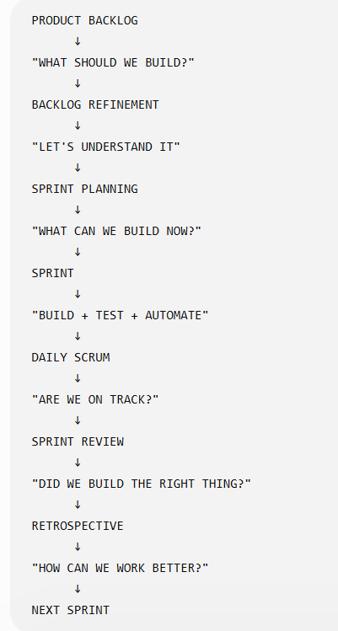
And your position as QA is not at the bottom waiting for developers to throw code over the wall.
You're inside the entire loop:
Requirement → Risk → Test → Automate → Break → Report → Verify → Improve.

